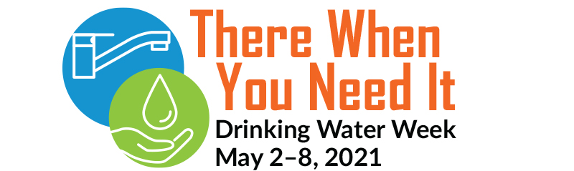

Drinking Water Week – Celebrating Tap Water and the Men and Women Who Make it Possible
The global pandemic brought attention to the fact that access to safe, high-quality tap water is essential to public health. And water industry professionals across Virginia ensured the taps kept flowing in 2020, despite unprecedented industry challenges, including staff shortages, closed customer lobbies, canceled community outreach and shifts in budgets, to name a few.
Use Drinking Water Week (DWW) as a time to come together and celebrate your essential workers’ successes and help them build confidence for the future. Employee appreciation and training go a long way to refuel team members and ensure preparation for whatever 2021 brings.
Here are a few ways to incorporate DWW with staff:
Host a digital trivia contest to boost company knowledge
Your workforce is your voice in the community. We all interact with customers, from meter technicians to wastewater line cleaning crews to the obvious customer service agent. Shape those daily conversations by training your team on your organization’s history, mission, and recent developments. Celebrate the trivia winners with lunch, swag, or an afternoon off! (Checkout the AWWA store).
Pause to complete safety training
The pandemic changed the way we interact with our co-workers. Social distancing, sanitation of workspaces and tools, and job site safety are more important than ever. It might seem impossible to pause with so much going on, but safety training is a great way to bring everyone together on a topic and focus on what’s essential: Employee well-being.
Encourage professional development
Employee professional development may increase employee satisfaction and reduce turnover. Let employees know that their individual growth is valuable to the organization. As a member of VAAWWA, they have access to training materials and webinars, mentorships, and professional networking. Learn more by emailing your VAAWWA representative, Geneva Hudgins, at geneva.hudgins@vaawwa.org.

Highlight employees on all media channels
Use what you got to highlight your employees. Whether that is a hallway posterboard, social media, email or your organization’s intranet, take the time to highlight anniversaries, promotions, retirements, and other milestones. Ensure team members know they can grow within your organization as others have.
Send out a press release
Use the VA AWWA Drinking Water Week Press Release template to send out a press release to your local news outlets. Encourage the local news media to highlight the work of the utilities employees and celebrate drinking water week publicly!
So not matter how you decide to celebrate DWW, let us come together to recognize all that tap water gives us and the men and women who make that possible. Thank you, Virginia water industry professionals, for keeping the food growing, communities thriving, and keeping us all going. Happy DWW!

