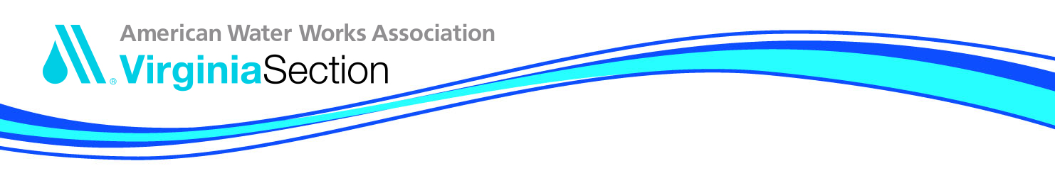

Small Systems Grants - Guidelines & Application

Rules established to define a small system and how the grant money would be distributed.
- System serving <= 3,000 service connections
- Grant money can only be requested/approved once per calendar year per person
- Must submit a valid Virginia operator's license number
- Email address required
- Funds can be used for any VA AWWA function (webinar, conference, teleconference, etc.)

Application Process
- Register for VA AWWA training you wish to attend. The individual should register as an Operator (if applicable) and select 'check' as the payment method. Registration must be completed by the Early-Bird deadline to be considered.
- Complete the SMALL SYSTEMS REGISTRATION GRANT APPLICATION and email to Geneva Hudgins at Geneva.hudgins@vaawwa.org.
- After the application has been reviewed to verify the applicant's eligibility, determine event meets requirements, and availability of funds, the applicant will be notified if the grant has been awarded.

Contact Information
Geneva Hudgins
VAAWWA Executive Director
PO Box 11992
Lynchburg, VA 24506

Phone: 434.386.3190
Email: Geneva.hudgins@vaawwa.org

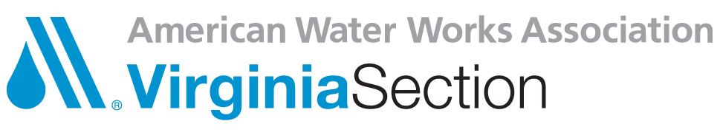
SMALL SYSTEMS REGISTRATION GRANT APPLICATION

Each year the Virginia Section AWWA Plant Operations Committee awards attendance grants to small water (Systems with less than 3,000 connections) utility employees. Selection is based on a first-come basis by registration for the training/event of VA AWWA. The grant amount is based on the registration fee for the event.

APPLICATION DEADLINE IS THE SAME AS THE EVENT EARLY REGISTRATION DEADLINE

Name
Utility
Address
City State Zip
Email
Phone

Current Position/Title
Current DPOR License Number
Water Facility PWSID Number
Work Experience

Education/Training You Wish to Attend

Please return to Geneva Hudgins, VA AWWA, P. O. Box 11992, Lynchburg, VA 24506 (Phone) 434.386.3190 (Email) Geneva.hudgins@vaawwa.org with your application for the training/event you wish to attend.

